Business Template

Recruitment agency

Contents
1 Business Description 3
1.1 Business background 3
1.2 Problems. Current Situation 3
1.3 The benefits of implementing a database. Project Vision 3
2 Model description 3
2.1 Definitions & Acronyms 3
2.2 Logical Scheme 3
2.3 Objects 3

Business Description

Business background
The Household Appliances Store operates as a retail and distribution business selling electronic appliances such as refrigerators, washing machines, TVs, air conditioners, microwaves, and similar household products.
The store collaborates with multiple international suppliers, manages inventory across different regions and cities, and serves both walk-in and online customers.
The company also employs sales representatives, warehouse staff, and management personnel responsible for daily operations.
The business handles purchases from suppliers, sales orders from customers, inventory movements, and payment transactions.

Problems. Current Situation
Currently, most store operations are tracked manually using spreadsheets and messaging tools.
This results in duplicated data, inconsistent pricing, difficulty managing stock levels, and delays in processing supplier deliveries or customer orders.
The lack of a unified system creates several issues:
Inaccurate inventory levels
Lost or inconsistent order information
Difficulty tracking supplier shipments and purchase history
Limited ability to analyze sales trends and product performance

the Benefits of implementing a database. Project Vision
Implementing a centralized database significantly improves daily operations and decision-making.
The system provides:
Accurate and real-time tracking of products, inventory movements, orders, and payments
Improved visibility into supplier performance and purchase operations
Reduced human error and elimination of data duplication
Clear insights into sales trends, customer activity, and product demand
Automated control of stock quantities and product warranties
The vision is to build an integrated solution connecting all key processes — from supplier purchases to customer orders and inventory management — ensuring efficient, transparent, and data-driven store operations.

Model description

Definitions & Acronyms
Term Definition
PK Primary Key
FK Foreign Key

Logical Scheme
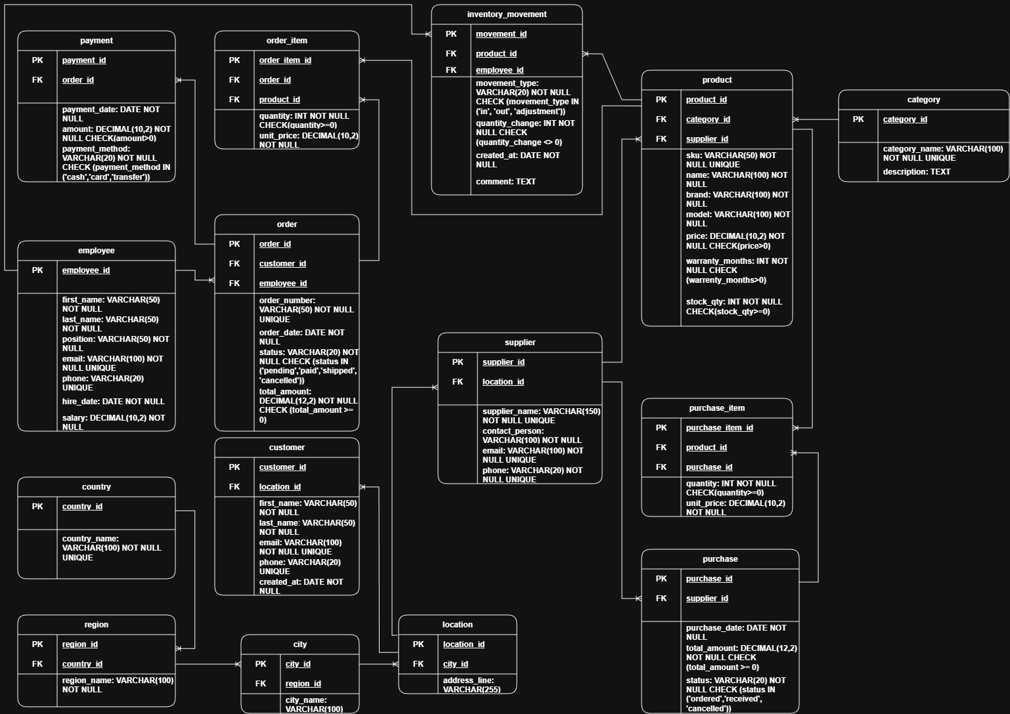

Objects
сountry Stores information about countries.
region Stores regions belonging to countries.
city Contains cities linked to regions.
location Stores detailed address locations used by customers and suppliers.
supplier Stores supplier information and contact details.
category Contains product categories.
product Stores product details, pricing, warranty, and stock information.
employee Contains information about store staff.
customer Stores customer profiles and contact details.
purchase Records purchases made from suppliers.
purchase_item Links purchased products to purchase orders.
order Stores customer orders.
order_item Links ordered products to customer orders.
payment Stores customer payment transactions.
inventory_movement Tracks stock movements (in, out, adjustments).

Table Description
Table Name | Field name | Field Description | Data Type
country | country_id | Unique country identifier (PK) | INT
 | country_name | Country name | VARCHAR(100)
region | region_id | Unique region identifier (PK) | INT
 | country_id | Reference to country (FK) | INT
 | region_name | Region name | VARCHAR(100)
city | city_id | Unique city identifier (PK) | INT
 | region_id | Reference to region (FK) | INT
 | city_name | City name | VARCHAR(100)
location | location_id | Unique address identifier (PK) | INT
 | city_id | Reference to city (FK) | INT
 | address_line | Full address text | VARCHAR(255)
supplier | supplier_id | Unique supplier identifier (PK) | INT
 | location_id | Reference to supplier address (FK) | INT
 | supplier_name | Supplier company name | VARCHAR(150)
 | contact_person | Supplier contact person | VARCHAR(100)
 | email | Supplier email | VARCHAR(100)
 | phone | Supplier phone | VARCHAR(20)
category | category_id | Unique category identifier (PK) | INT
 | category_name | Product category name | VARCHAR(100)
 | description | Category description | TEXT
product | product_id | Unique product identifier (PK) | INT
 | category_id | Reference to category (FK) | INT
 | supplier_id | Reference to supplier (FK) | INT
 | sku | Unique stock-keeping unit | VARCHAR(50)
 | name | Product name | VARCHAR(100)
 | brand | Brand name | VARCHAR(100)
 | model | Product model | VARCHAR(100)
 | price | Product price | DECIMAL(10,2)
 | warranty_months | Warranty in months | INT
 | stock_qty | Current stock quantity | INT
 | created_at | Date product was added | TIMESTAMP WITH TZ
 | comment | Additional notes | TEXT
employee | employee_id | Unique employee identifier (PK) | INT
 | first_name | Employee first name | VARCHAR(50)
 | last_name | Employee last name | VARCHAR(50)
 | position | Job position | VARCHAR(50)
 | email | Employee email | VARCHAR(100)
 | phone | Phone number | VARCHAR(20)
 | hire_date | Employment start date | DATE
 | salary | Employee salary | DECIMAL(10,2)
customer | customer_id | Unique customer identifier (PK) | INT
 | location_id | Reference to customer location (FK) | INT
 | first_name | Customer first name | VARCHAR(50)
 | last_name | Customer last name | VARCHAR(50)
 | email | Customer email | VARCHAR(100)
 | phone | Customer phone | VARCHAR(20)
 | created_at | Customer registration date | TIMESTAMP WITH TZ
purchase | purchase_id | Unique purchase identifier (PK) | INT
 | supplier_id | Reference to supplier (FK) | INT
 | purchase_date | Purchase date | DATE
 | total_amount | Total purchase amount | DECIMAL(12,2)
 | status | Purchase status | VARCHAR(20)
purchase_item | purchase_item_id | Unique purchase item ID (PK) | INT
 | product_id | Reference to product (FK) | INT
 | purchase_id | Reference to purchase (FK) | INT
 | quantity | Quantity purchased | INT
 | unit_price | Unit purchase price | DECIMAL(10,2)
order | order_id | Unique order identifier (PK) | INT
 | customer_id | Reference to customer (FK) | INT
 | employee_id | Reference to employee (FK) | INT
 | order_number | Unique order number | VARCHAR(50)
 | order_date | Order creation date | TIMESTAMP WITH TZ
 | status | Order status | VARCHAR(20)
 | total_amount | Order total amount | DECIMAL(12,2)
order_item | order_item_id | Unique order item ID (PK) | INT
 | order_id | Reference to order (FK) | INT
 | product_id | Reference to product (FK) | INT
 | quantity | Quantity ordered | INT
 | unit_price | Unit sale price | DECIMAL(10,2)
payment | payment_id | Unique payment identifier (PK) | INT
 | order_id | Reference to order (FK) | INT
 | payment_date | Payment date | TIMESTAMP WITH TZ
 | amount | Payment amount | DECIMAL(12,2)
 | payment_method | Payment method | VARCHAR(20)
inventory_movement | movement_id | Unique movement identifier (PK) | INT
 | product_id | Reference to product (FK) | INT
 | employee_id | Reference to employee (FK) | INT
 | movement_type | Type of movement | VARCHAR(20)
 | quantity_change | Stock change value | INT
 | created_at | Movement date | TIMESTAMP WITH TZ
 | comment | Additional notes | TEXT

country → region: One country can have many regions.
region → city: One region can include many cities.
city → location: One city can contain many locations.
location → supplier / customer: One location can belong to many suppliers and customers.
supplier → product: One supplier provides many products.
category → product: One category contains many products.
supplier → purchase: One supplier can have many purchase orders.
purchase → purchase_item: One purchase includes many purchased products.
product → purchase_item: One product can appear in many purchase items.
customer → order: One customer can place many orders.
employee → order: One employee can manage many customer orders.
order → order_item: One order includes multiple ordered products.
product → order_item: One product can appear in many order items.
order → payment: One order can have one or more payments.
product ↔ inventory_movement: One product can have many inventory movements.
employee → inventory_movement: Employees can create many inventory movement records.

Example with data

product_id | name | brand | price | category | supplier
1 | Refrigerator A+ | Samsung | 800 | Refrigerators | TechDistributors LA
2 | Washer Pro | Bosch | 450 | Washing Machines | Bavaria Wholesale
3 | Smart TV 55" | LG | 1200 | TVs | Paris Electronics

